**Project Title: Social Media Auto-Comment AI Bots (Instagram & Facebook)**

**Brief Description:** Developed AI-driven Auto-Comment Bots for Instagram and Facebook to enhance social media engagement by automating comment responses. These bots utilize OpenAI's ChatGPT to generate intelligent and contextually relevant replies, ensuring consistent interaction with followers. The Instagram Auto-Comment Bot manages and responds to comments on posts, while the Facebook Auto-Comment Bot handles comment replies on Facebook Pages. Both solutions streamline community engagement, allowing users to nurture their follower base effortlessly.

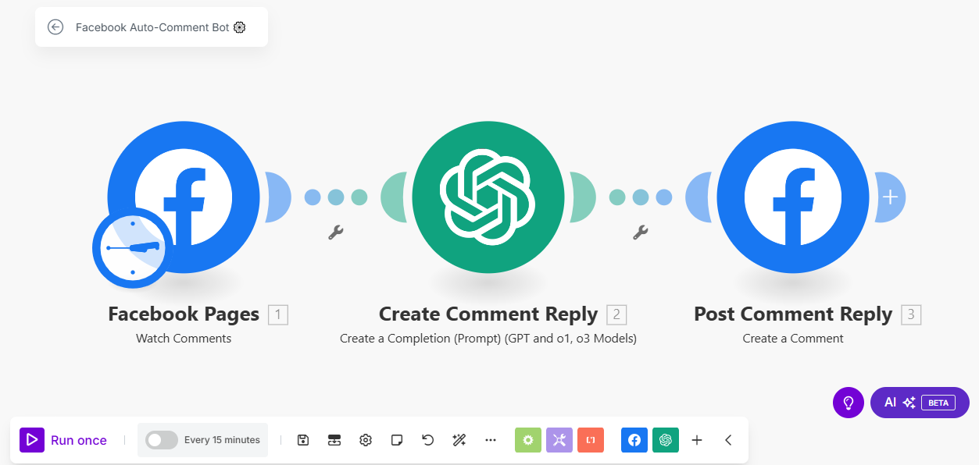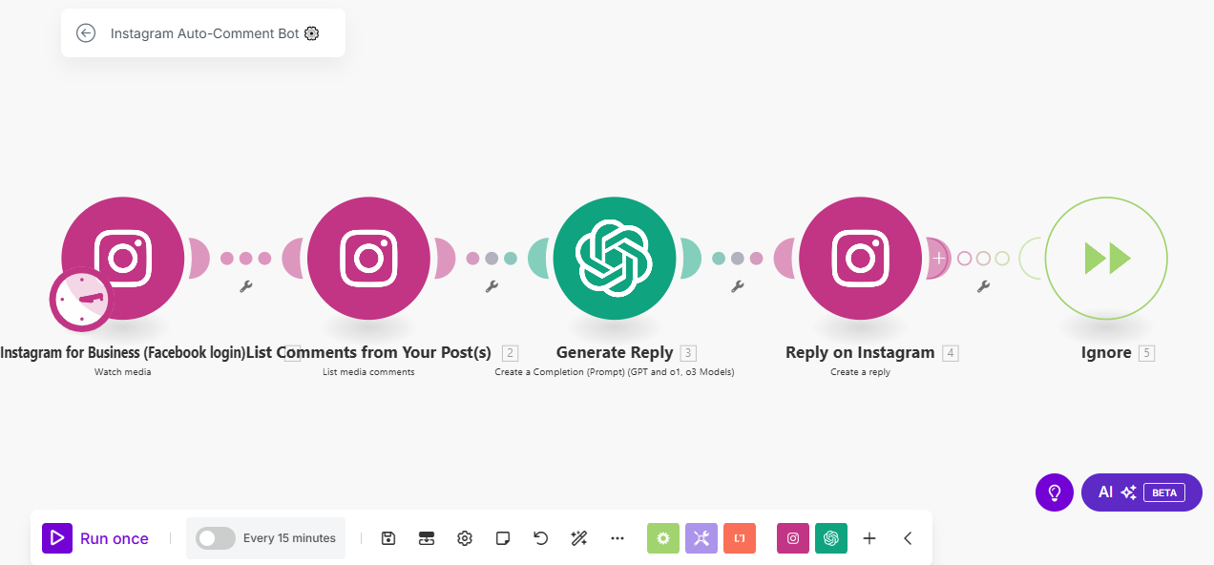

**Skills Used:** AI content generation, social media automation, comment management, and workflow optimization using Make.com. The bots integrate OpenAI's ChatGPT for intelligent reply generation and respective social media APIs for seamless comment interaction.

**Relevant Outcomes/Achievements:** Successfully implemented zero-coding, plug-and-play solutions that run on autopilot, making them accessible for users without technical expertise. The bots' ability to generate and post replies every 15 minutes ensures consistent engagement with followers. These projects have enabled users to enhance their social media presence, leading to increased follower interaction and community growth. The fully customizable nature of the bots allows users to tailor responses to specific audiences, ensuring relevance and impact.

Key Features:

* Automated comment response generation using AI.
* Integration with OpenAI's ChatGPT for intelligent and contextually relevant replies.
* Seamless interaction with Instagram and Facebook comments.
* Fully customizable and adjustable to meet specific engagement requirements.
* Zero coding required, ensuring ease of use for non-technical users.